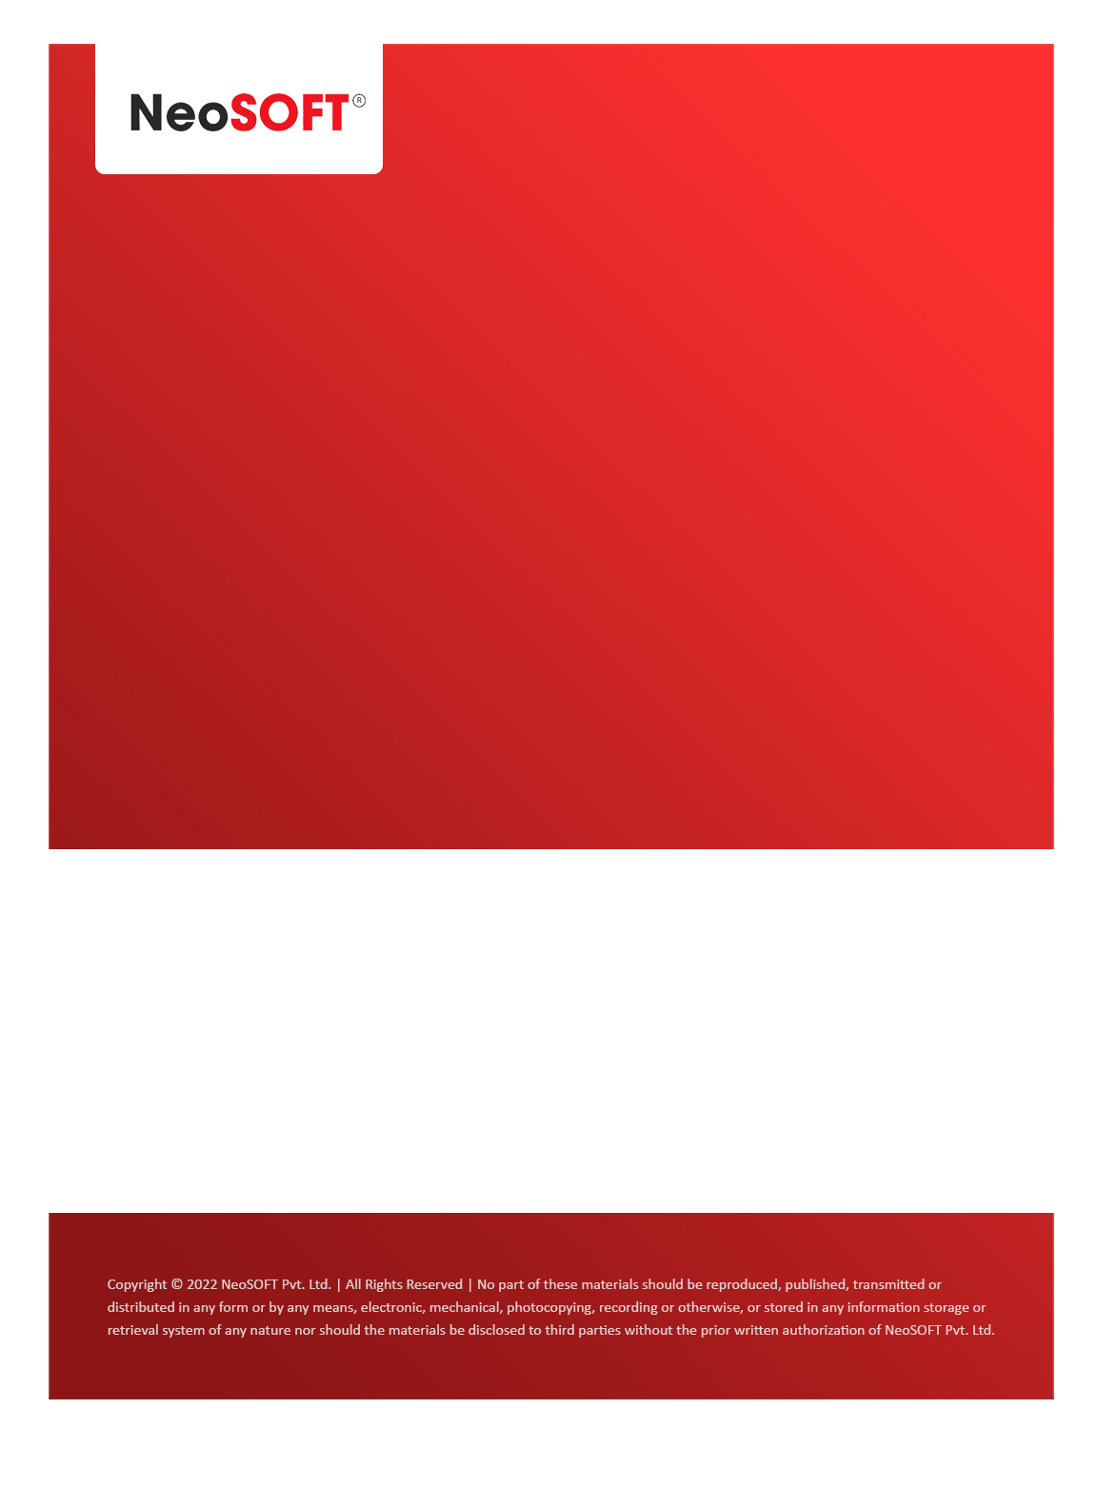`

**Eltizam MOM – Project Status meeting**

Eltizam

Client Name

NeoSOFT is a SEI-CMMI Level-5 Global IT Consulting & Software Solutions Provider

**15th June,** 2023

|  |  |
| --- | --- |
| **Meeting Date, Time, and Attendee Details** | |
| **Date** | 15th June 2023 |
| **Venue** | MS Teams |
| **Time** | 02.00 PM – 02.30 PM IST |
| **Meeting Type** | Wireframes Review, SRS document updates, Project status |
| **Internal Attendees** | * YallaReddy * Akshata * Nikita Lomate |
| **Client Attendees** | * Karuna Pawar |
| **Presented By** | * Karuna Pawar |
| **MOM Prepared By** | * YallaReddy |

|  |  |
| --- | --- |
| **Details of Meeting** | |
| **Sr. No.** | **Description** |
| 1 | Discussed review feedback comments for BA completed work. |
| 2 | Karuna mentioned that, Master modules wireframes review session done with client and Evaluation process screens yet to review. |
| 3 | Waiting from Karuna to get information on   * Evaluation Assessment form * Invoice receipt * Payment receipt details. |
| 4 | Discussed that on master modules wireframes, we are fine to start design phase. So once approval email provided by Vinod & team then, we will start design in coming days. |
| 5 | Evaluation modules will be reviewed & finalized by end client in parallel. So, we will start Design & Development. By that time, we will get confirmations on pending modules. |
| 6 |  |
| 7 |  |

|  |  |  |  |  |  |
| --- | --- | --- | --- | --- | --- |
| **Actionable** | | | | | |
| **Sr. No.** | **Action Item** | **Assigned to** | **Assigned Date** | **Expected Completion Date** | **Status** |
| 1 | Vinod & team will send an email for approval on Master module wireframe. So we will start Design. | Eltizam team |  |  |  |
| 2 |  |  |  |  |  |
|  |  |  |  |  |  |